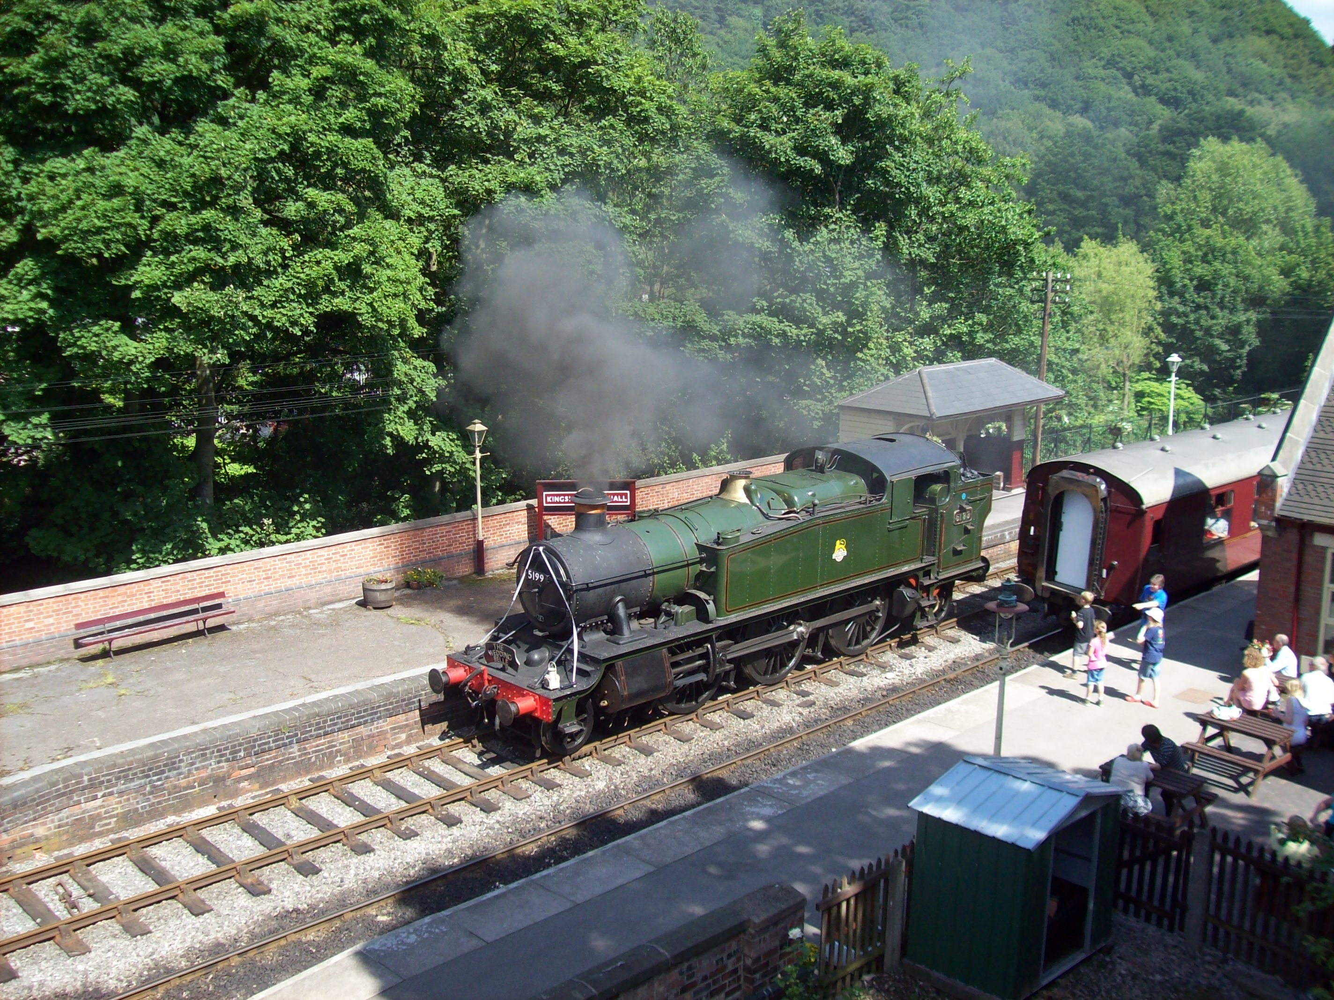

Newsletter No. 16
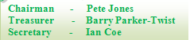
Wrexham Area Group

A Prairie tank runs round its train on the Churton Valley Railway in glorious June sunshine. The ribbons adorning (or spoiling!) the front of the loco were attached as the train was about to haul a ‘wedding special’ up the branch. The sleeper spacing looks somewhat uneven!

Meeting held Wednesday 31st August 2011 at Maesgwyn Community Centre, Wrexham

Present were Roger, Rowland, Pete, Ian, Kevin, John and Jonathan. Barry was on his way back from holiday in Aberystwyth so we had no baseboards to work on.
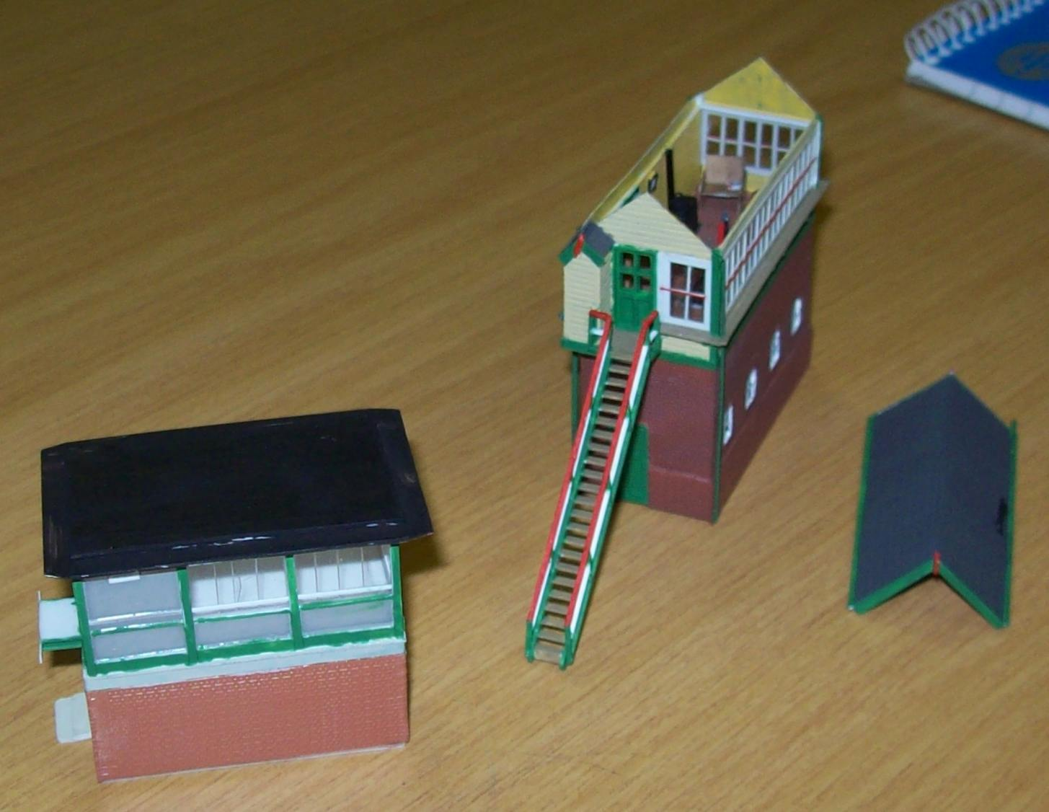
Rowland brought along his scratch built models of Colwyn Bay East & West signal boxes. The west box (the smaller one with the flat roof) is not yet completed but the east box is a beautiful model with interior detail including correctly coloured signal and point levers, stove and cat sitting on the signalman’s chair.

Rowland plans to incorporate correct signal levers and track plan in the west cabin and was looking for details of the structures outside the box. Dave Gibbons of the Chester “C” Group has provided the answer by lending Rowland a book on the LNWR which gives the details. It turns out that the structures are coal and ash bunkers.

Roger had brought along the Bachmann TPO Mail coach. This is the one with recessed doors and working orange lights on the side. The pick-ups for operating the lights are hardly noticeable as they contact the tops of the bogie wheels. A very neat piece of manufacturing.

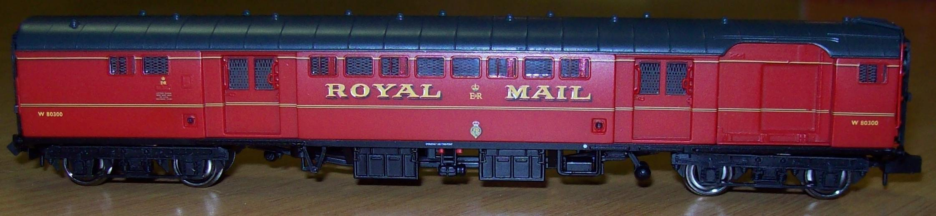

Ian announced that he had now cleared his garage sufficiently to allow a couple of the “Bryn-y-Mor” layout boards to be assembled and worked on. This will give us more hours to work on the layout than the 2½ hours per month that we have at Maesgwyn. It will also mean that we can leave work and return to it without its having been disturbed in the meantime (useful for gluing, ballasting and painting). It was agreed that we would reserve each Wednesday evening, except the last Wednesday in the month, for this purpose.

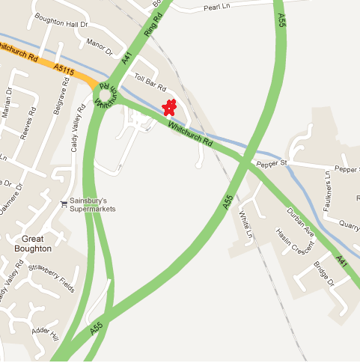
Ian’s address is 17 Toll Bar Road, Christleton. CH3 5QU (as in the N Gauge Society adverts in the model railway press. A sketch map is shown below but directions are fairly straightforward. From the intersection of the A483 and A55, take the latter road northwards and take the next exit marked ‘Whitchurch’. This brings you to the infamous “Sainsburys Roundabout, which is currently being transformed into a traffic light controlled junction. At whatever stage the roadworks have reached, turn right onto the A41 Whitchurch Road and first left after a hundred yards and a flashing 30 mph sign into Toll Bar Road. Ian’s house is on the left about 80 yards up the road. It’s 15 minutes drive from Maesgwyn. You may need to park on the road a few houses away as at least three of the neighbours are taxi drivers and leave their cabs in the road.

Ian mentioned to Kevin that he may like to phone Ian before setting out as access to the garage may be limited as the two driveways now house up to five cars.

The first of the Wednesday meetings will be this week,
i.e. 7th September

Layout meetings each Wednesday evening from 7:00 p.m. at Toll Bar Road

Next meeting at Maesgwyn – Wednesday 28th September at 7:30 p.m.

