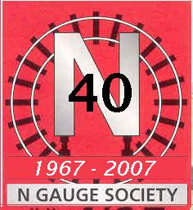
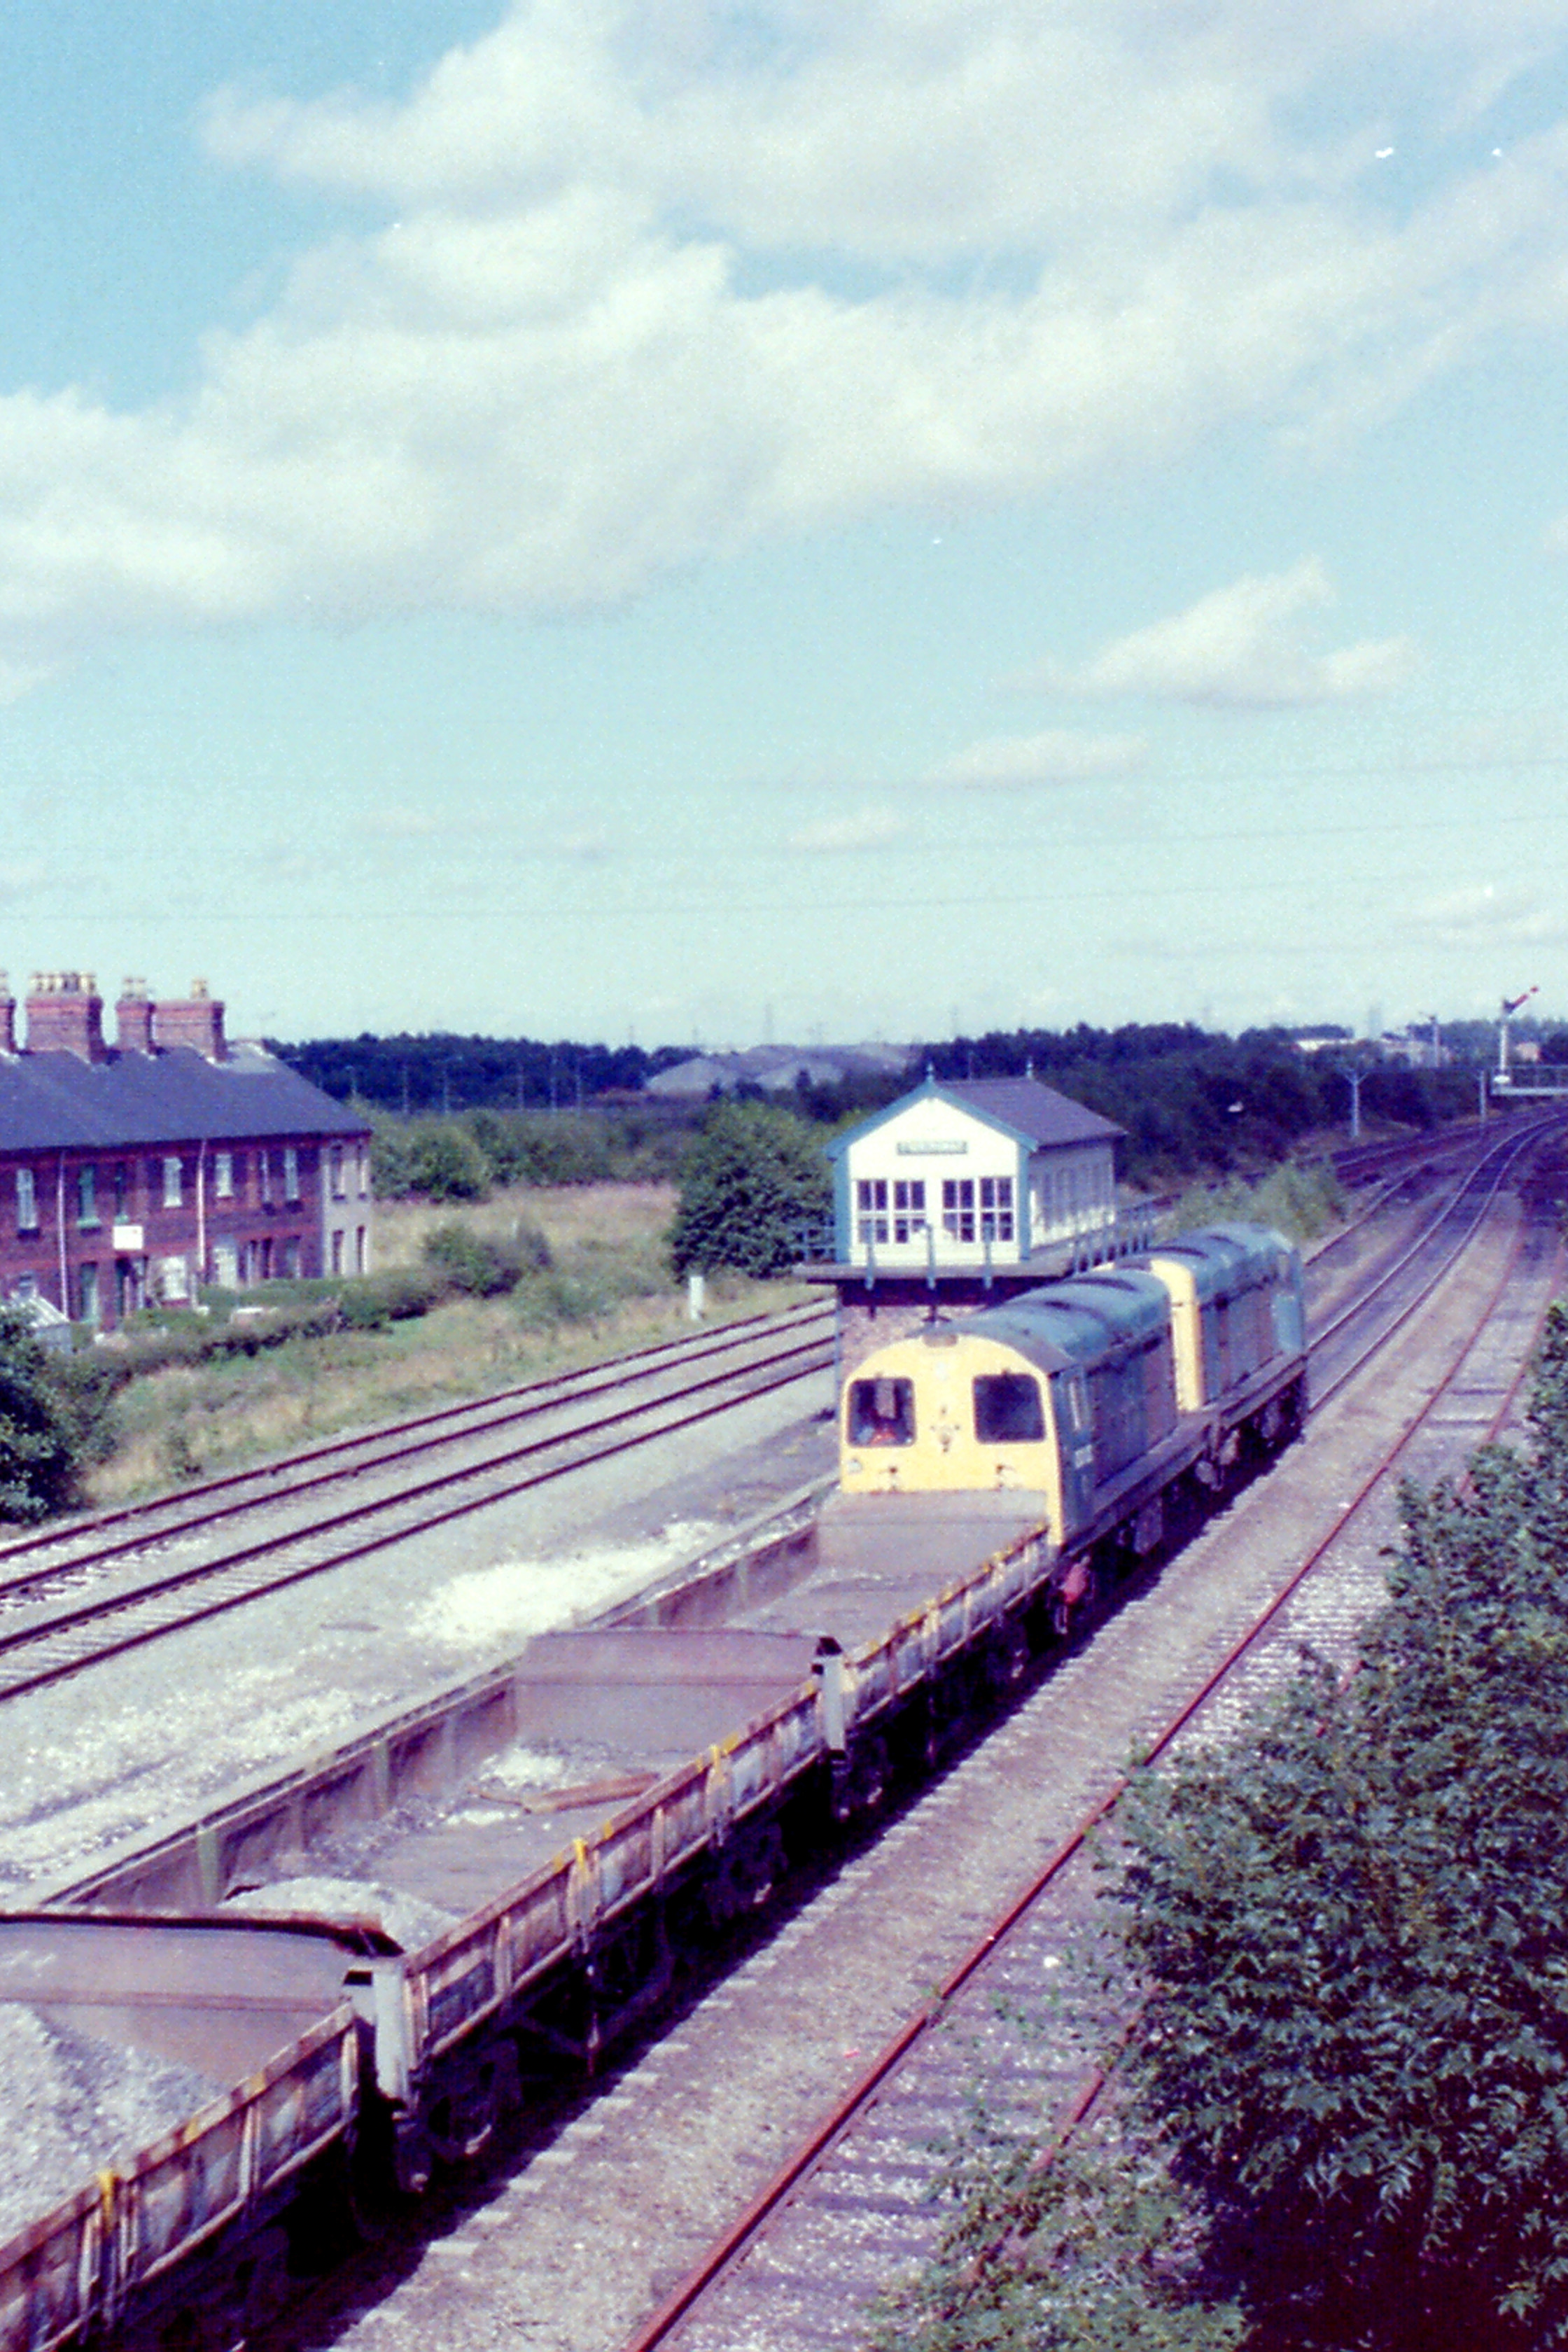
N GAUGE SOCIETY

Wrexham Area Group Newsletter No.3

Chairman - Pete Jones.
Treasurer – Barry Parker Twist
Secretary – Ian Coe

Meeting held Wednesday 30th June 2010
at Maesgwyn Community Centre, Wrexham

Although Glyn was not present, numbers were made up by two potential new members - Lee from Rossett and Carl Drinkwater from Ellesmere joining Roger Smith, Pete Jones, Barry Parker-Twist, Roland Lewis, Kevin Woolmore, John Edwards and Ian Coe. Carl had seen the Group mentioned in the latest Journal and decided to come along and see what we were up to. Hope we haven’t put you off Carl! Lee had previously been to the Chester Group meeting at Dodleston (having walked there!) and had also come to see what the new Group was like. As has previously been mentioned, there is likely to be an overlap between the Chester and Wrexham Groups but as long as you are happy to pay your subs to both groups, you are quite welcome to both sets of meetings. You will need to decide which group is your principal one though as Area Groups claim a grant from the Society in October and can only claim once per member so you need to let your Group secretary know which Group is claiming your grant.

To further enhance this bond, we have in mind setting up the Chester Group’s “Cragmill” layout in Barry’s new railway room (when it is completed – late August?). Both Groups can then have a “running evening” at Barry’s in Cefn Mawr from time to time.

This was our third meeting and we still haven’t been presented with a bill for the hall hire – (hope our Treasurer has invested our subs wisely on the Money Market!).

As the Society’s New Members Secretary, Ian receives request for Introductory Packs from potential new members responding to the Society’s adverts in the model railway press. These can be as short as an address on the back of a cheque to an essay incorporating the life history of the applicant. On the day of the meeting, Ian had just received one of the latter requests, which he passed to John to read out to the gathered members. To save any embarrassment to the enquirer, a précis is given below with some details left out.
“Dear N Gauge Society

Could I get a list of EMUs and DMUs South West Trains use or used from 1998 – present and where could I buy them. My membership Form will be sent to you soon as I’m out of work and have 7 children to feed. But don’t worry – it’s filled out and ready to go (just the money to add) and also could I get a bit of info of how to create a 2-level layout. My layout plans are on the back and also a little about each section to give you an idea of what it will look like.

Yours in modelling
……………………………”

There then follows FIVE PAGES of layout description of what is a fictional London terminus feeding a further seven stations built on 17 baseboards with two fiddle yards of 12 and 20 roads!

Now if the letter had come from Rod Stewart it is plausible but from an unemployed Irishman with seven children I think we are dreaming a little!

How do you reply to that? Well Ian has taken the easy option and sent him a copy of Grahame Hedges “N’spirations” suggesting he might like to contact the author for more assistance! It’s cheaper than spending time trying to answer all his questions.
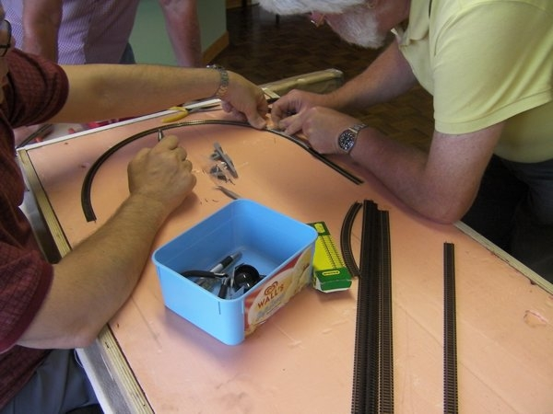

The evening was to be spent putting together a test track for running our models at future meetings although there are already suggestions flying about to build an exhibition layout!

We had two boards to work on both just under 4’ x 2’. One a piece of builders foamboard (used in insulating buildings) and framed with ½inch ply. The other board was more traditional with a ply base (making pinning track to it more time consuming – especially as we could only muster a toffee hammer between us).

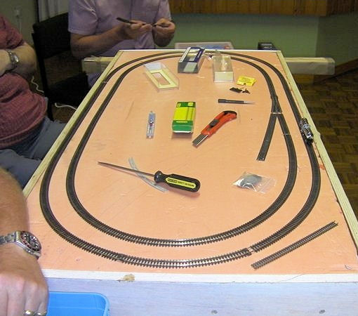
We split into two teams with John, Kevin, Roger and Ian working on the foamboard whilst the rest worked on the other board or looked on. The idea was to build two circuits of track with the inner track having a minimum radius of 9 inches. With the easier task on the foamboard, John’s team had finished and put in a siding whilst Barry, Pete and Rowland were still pinning down their outer circuit.

Ian used one of his “silver bullet” bogie tank wagons as a track tester – it rolled round the layout without incident.

There was a subtle change in the design of the other board and it looks as if they are intending to build a further board to adjoin the first. Thanks to Pete for taking the photos and to whoever provided the track pins and rail joiners. Also thanks to Roger for providing some chocolate biscuits and offering a book for sale with a proportion of the proceeds going to Group funds. This is something we could consider for a future meeting with members bringing in surplus items of railway/model railway related items for sale with profits going to the Group coffers – especially if we decide to embark on building an exhibition layout.
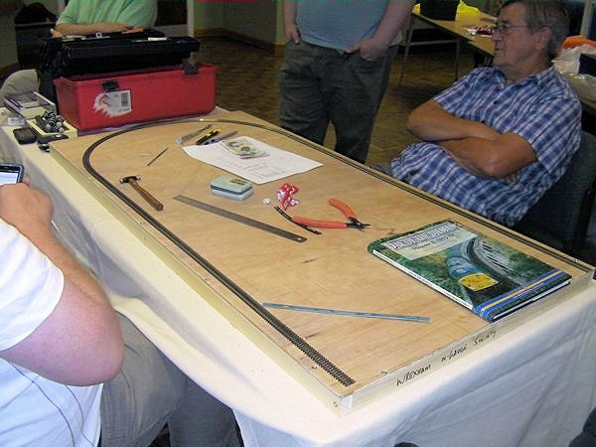
There was some concern that clicking on the link for the Wrexham Area Group on the Society website brought up the Yorkshire Area Group page – not good for recruiting new members! Thanks to the intervention of Mike Bloomfield, this has now been sorted.

Date of next meeting – Wednesday 28th July at 7:30 p.m.

